WEEK 4 DNS & OSINT FOOTPRINTING

Fig: 1Whois results
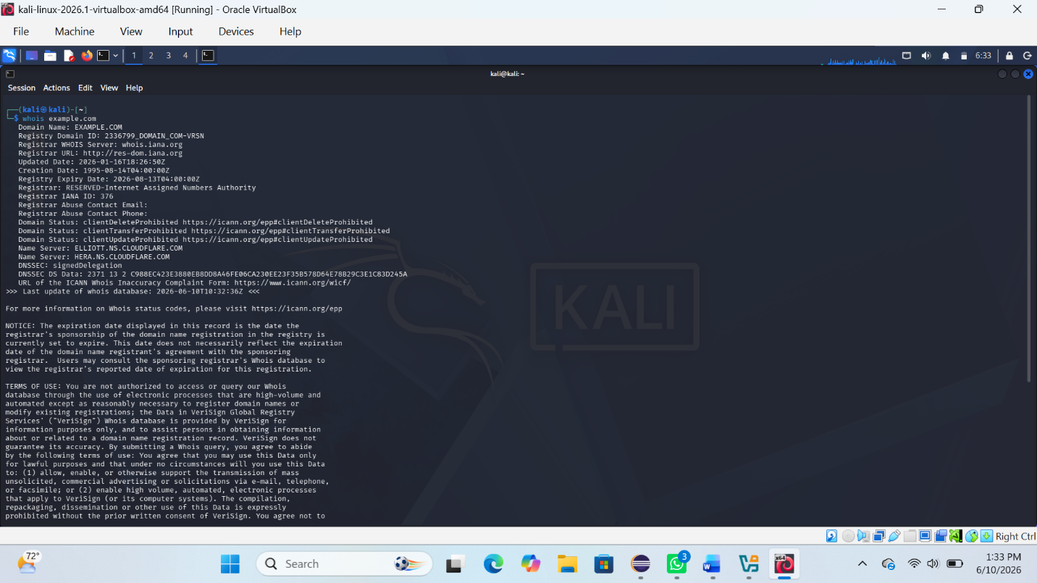
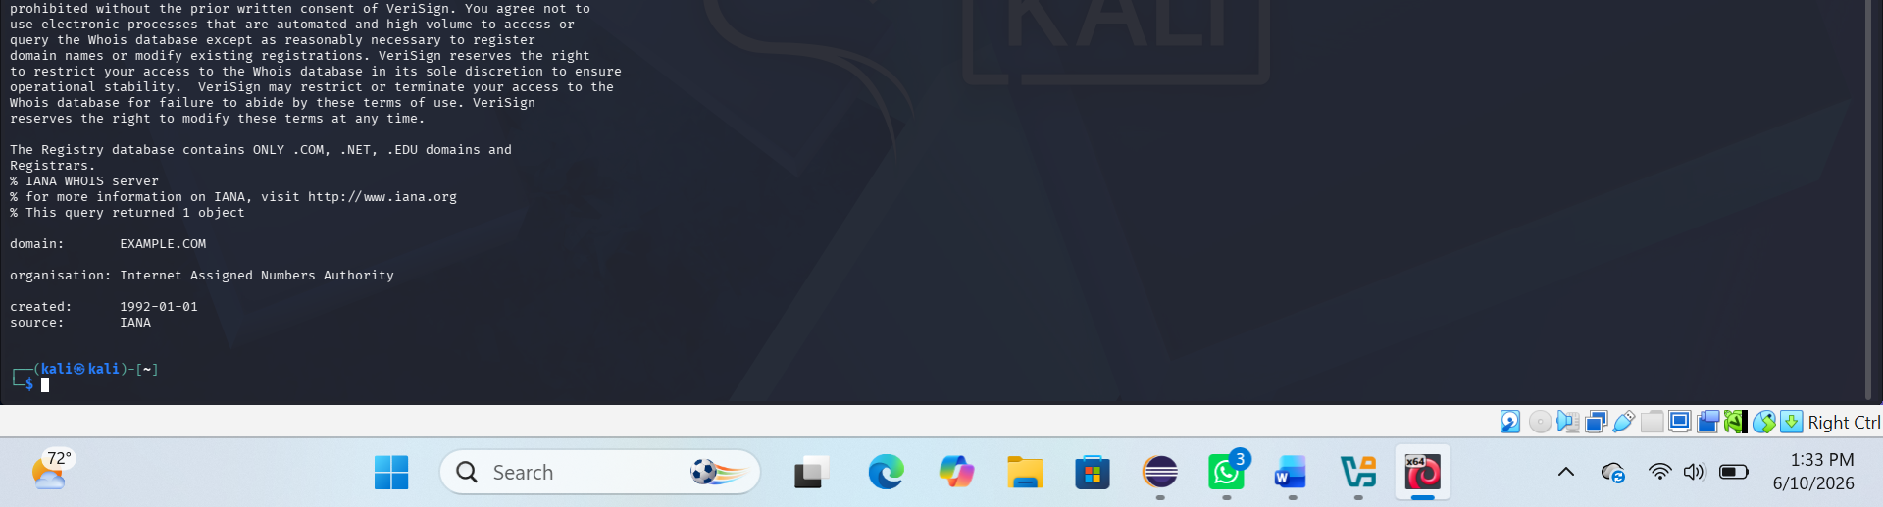

Fig 2:DNS information gathering
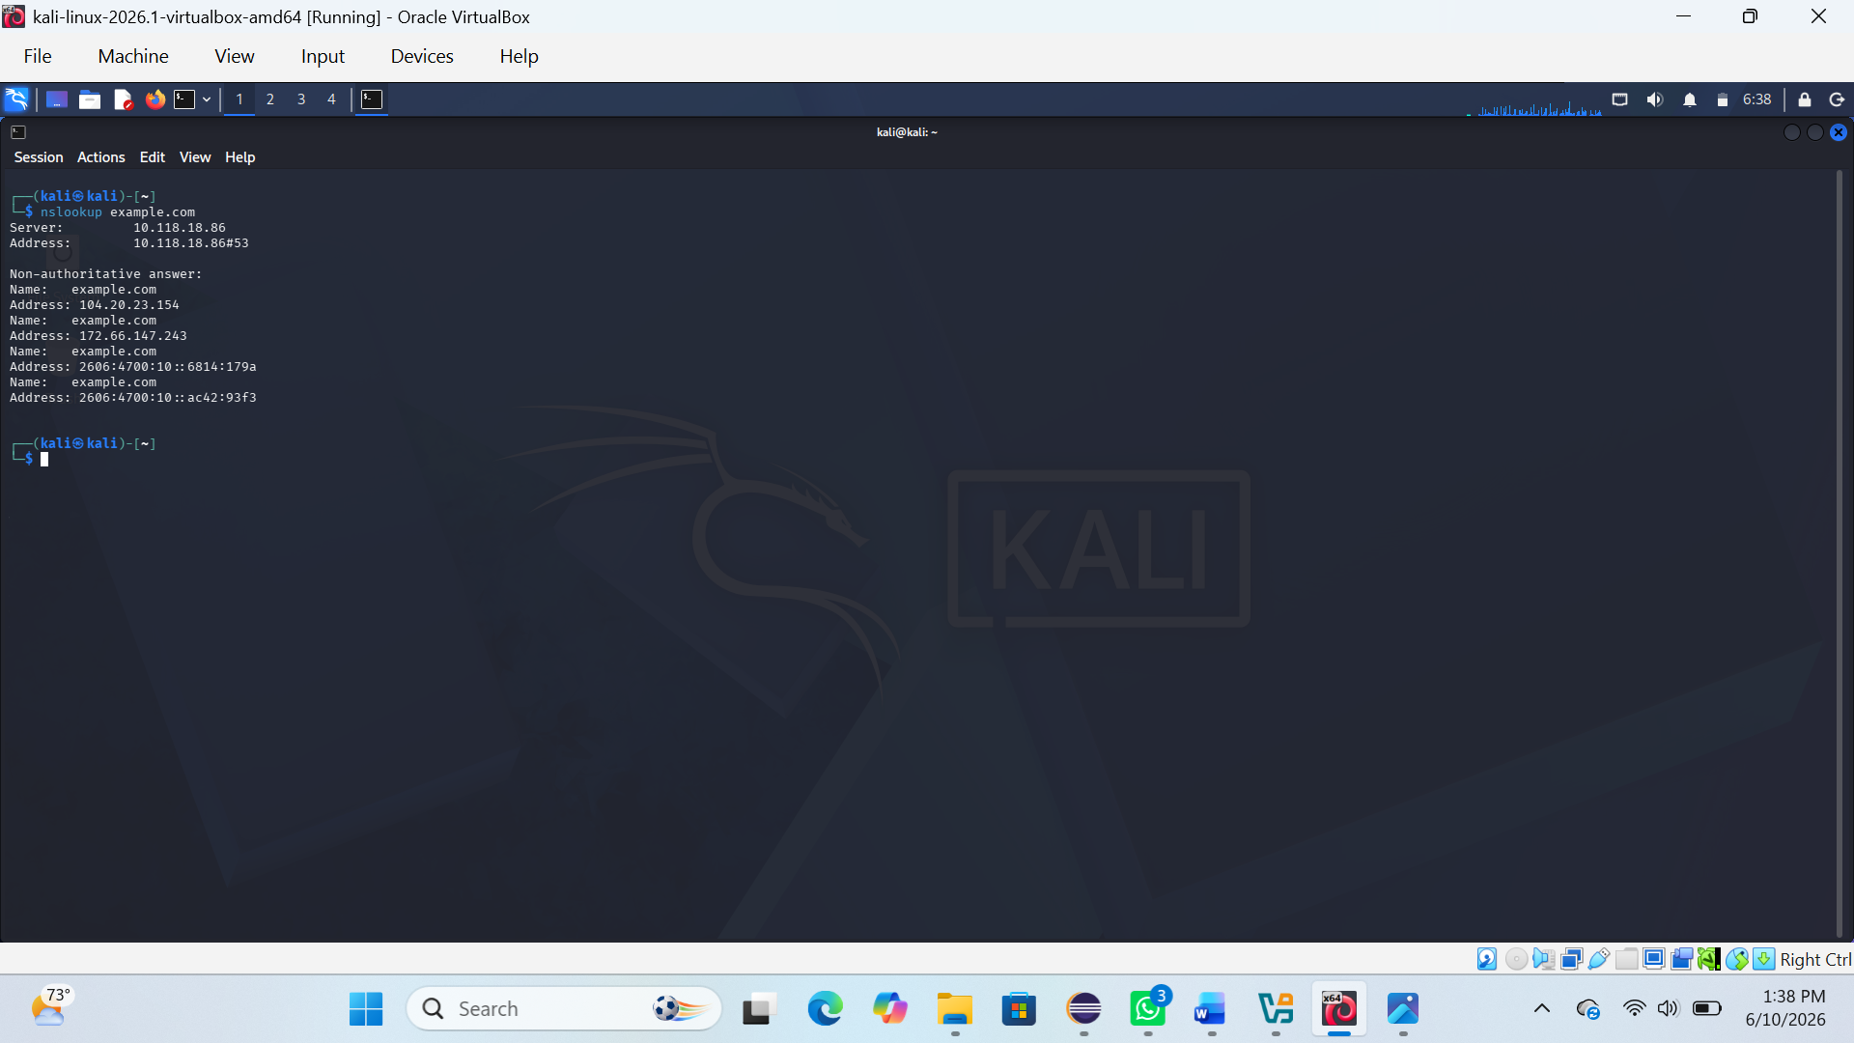

REFLECTION:
I learned how DNS and WHOIS tools help collect domain information and understand network structures during reconnaissance.

